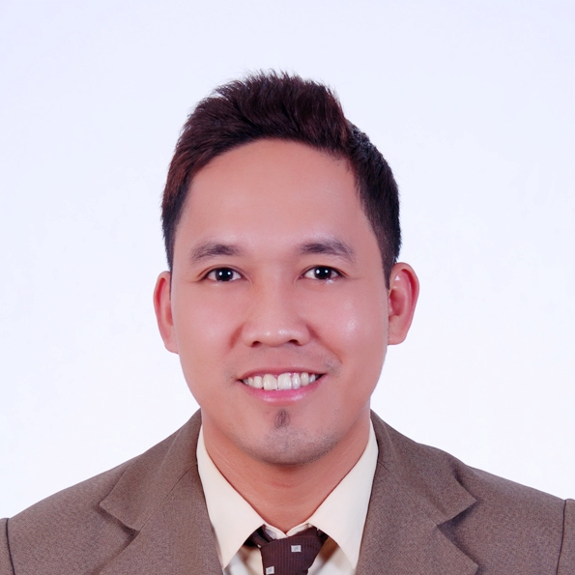

WILFREDO R. GRIMALDO JR
Calmar Homes Subd. Kanlurang Mayao, Lucena City
Quezon Province, Philippines
Email Add: wrgrimaldo@yahoo.com
Mobile No. +639328925808 / +639272950976

OBJECTIVES:
To find a stable yet challenging position in a professional environment in which to learn new technologies and skills while utilizing my previous experiences to improve beyond my current abilities.

WORK EXPERIENCE:

COOPERATIVE BANK OF QUEZON PROVINCE
HEAD OFFICE
Granja cor Leon Guinto sts., Lucena City
Tel. No. (042) 797-0663 / 373-5103 / 660-2125

Accounting Officer I (August 2014 up to present)
- Responsible in overseeing the accounting functions of the HO operations to provide the management and other internal users with accurate, complete, relevant and timely financial information to be used in decision making.

- Assist the Manager in the operations, such as act as Reliever in his/her absence, thus performs overrides in the CASA withdrawals and other non-cash transactions based on authority given and preparation of financial budget , analysis of financial condition.

- Provides assistance as reliever in the absence of any employee at the operational level or as support staff in case of manpower shortages.

- Responsible in the preparation of periodic financial reports and ensuring compliance of financial reporting requirements for submission to government regulatory bodies ( e.g. BSP, PDIC, BIR, CDA) and to the management in accordance with the Phil financial Reporting Standards and Phil Accounting Standards (PFRS and PAS).

- Responsible in the preparation of working papers and other related requirements for interim, internal, year-end external audits and BSP’s annual general examination.

- Responsible in ticketing, checking, posting, recording and balancing of transactions including , encoding and closing of month end reports manually and GL integrated accounting system.

- Checks accuracy and completeness of cash withdrawals, check encashment, loans repayments, loan releases , including documentations

- Undertakes regular reconciliation of books of accounts , unannounced cash counts of cash in vault and petty cash funds and physical inventory of accountable forms and FFE

- Attends to the systematic filing of daily transactions and all related accounting records and monitors the required retention period of such files/records

Operations Associate (August 2011 up to July 2014)
- Undertakes administrative, general services and clerical support as well as staff assistance such matters as data collection and collation and technical support on regular functions, special projects, and activities being undertaken by the branch/work unit.
- Provides assistance as reliever/trainer to all new employee to the positions of the cashier, accounting associate, accounting assistant, teller, loans clerk, customer relations assistant, in the absence of any employee at the operational level or as support staff in case of manpower shortages.
- Provides liaison, coordination, and follow-up with other work units as directed by the superior.
- Encodes and prints materials, documents and reports as may be needed in the course of banking operations.
- Files documents and records according to established classifications; Keep updated files with particular emphasis on the maintenance of confidentiality of classified information.
- Assists other employee at the operational level on their regular activities related to disbursement, ticket preparation, deposit withdrawal/ encashment of check, loan releases, and receipt of loan repayments.

Audit Assistant (September 2010 up August 2011)
- Conduct transaction testing and assessment of specific internal control procedures.
- Conduct operation audit to branches such as unannounced cash count and physical inventory of the bank assets including collateral being held in support of the loan.
- Check computations on releases/payments to ensure correctness and accuracy of cash transaction. Verifies interest rates given to loan and interest given to deposits.
- Conduct balance verification thru sending of confirmation letters to borrowers and depositor anytime of the year.
- Check the Post Dated Checks under the custodian and see to it that all checks are properly deposited on its date and ensure that all returned checks were transferred to CLAM section for collection.
- Shall impose control and compliance of daily operation such that;
- All transaction are properly ticketed, verified and approved.
- SL, GL and computer balances of selected accounts are updated & reconciled.
- Approving level per transaction is followed.
- Gather information from outside thru field audit affecting the bank transaction.
- All audit findings that has been recorded must be reported to the audit supervisor and discussed the same with the employee concerned with the presence of the manager for his/her information.

Central Accounting Assistant (October 2009 – September 2010)
- In charge of central clearing of all ICC’s of the bank.
- Process all ICC’s received from clearing bank.
- Prepares tickets and other supporting schedule.
- Assist/participates in the safekeeping of central accounting records and reports.
- Generates the Consolidated Daily Trial Balance
- Take charge in the consolidation of back ups for Management and BSP reports.
- Prepares and submits all required reports ahead of schedule (at least one week before set deadline by the management)
- Management Reports
- BSP, PDIC Reports (Monthly, Quarterly, Annually)
- FRP-PAS Reports (Internal and BSP Reports per schedule)

COOPERATIVE BANK OF QUEZON PROVINCE
LUCENA CITY BRANCH-MFOB
Dona Victoria st., Lucena City
Tel. No. (042) 660-2125 / 373-0086

GL Bookkeeper (April 2008 to October 2009)
- Performs the audit function as checker of the day-to-day transaction and observes the bank’s internal control measures.
- Sees to it that the books of accounts are balanced daily and no items left unreconciled at end of day.
- Prepares all the required reports by the management, BSP and other FI’s.
- Attends to systematic filing of books of accounts and other accounting records.
- In charge in the registration of Books of accounts and payment of local taxes.
- Acts as alternate or reliever in the absence of the Bookkeeper (Savings,Time,PSD,Loans)
- Acts as OIC of the branch as instructed by the BM or GM.

Loans Bookkeeper (January 2002 to April 2008)
- Encode micro and regular loan releases to computer program.
- Maintain all the subsidiary ledgers of all micro finance accounts and regular accounts.
- Subsidiary ledger of Past Due Accounts are stamped as such, and kept in a separate file.
- Encode all loan payments and its proper application to the computer and post to ledger.
- In charge in the computation of necessary charges of arrears and past due accounts.
- Ensures that the computer and subsidiary balances being maintained tallies with the record of the GL.
- Prepares notices/letters to borrowers with arrears and with past due loan.
- Keeps the pin and password of all loan program.
- Ensures that the subsidiary ledgers and back up files ere securely kept inside the vault.
- In charge in the preparation of all computer generated reports.
- Complies with the reporting requirements needed by the MIS unit.
- Prepares Month End Report to be submitted to Collection and Loan Department

REACH OUT FOOD SALE CORPORATION (FRANKS N’ BURGER)
Maharlika Hi-way, Brgy. Talipan Pagbilao Quezon
Tel. No. (042) 710-5013
Designation : Management Trainee (June 2001 to December 2001)

EDUCATIONAL BACKGROUND:

Tertiary : Manuel S. Enverga University Foundation
Bachelor in Science in Business Administration
Major in Management Accounting
University Site – Lucena City
Year 1997 - 2001

CHARACTER REFERENCES:

Angelina C. Lontoc Meleniza D. Mazo
Bank Operation Officer Branch Cashier
Cooperative Bank of Quezon Province Cooperative Bank of Quezon Province
Granja cor Leon GUinto Sts., Lucena City A. Bonifacio St., Gumaca Quezon

ACHIEVEMENTS:

- CBA Deans Lister 2nd Sem. 2000 – 2001
1st Sem. 2000
2nd Sem. 1998 - 1999

- Service Medal Awardee March 1999
CWS Expanded ROTC Program

- College Scholar 2nd Sem. 1998 – 1999

- University Scholar 1st Sem. 1997

PERSONAL INFORMATION:

Nickname : Willy
Age : 38
Gender : Male
Marital Status : Married
Height : 5’7”
Weight : 160 lbs.
Nationality : Filipino
Birthdate : September 29, 1980
Place of Birth : Sta cruz, Marinduque

I hereby certify to the correctness of the above information.

WILFREDO R. GRIMALDO JR
Applicant

